NAME : BALA VIJAY S
REG.NO : 192424160
Dept. Name : CSE -AIDS
Course Code : DSA06
Course Name : Data Handling and Visualization

1. Create a line chart to visualize the monthly sales. Label the axes and title the chart appropriately.

# Monthly Sales Dataset
month <- c("January", "February", "March", "April", "May")
sales <- c(15000, 18000, 22000, 20000, 23000)

# Create line chart
plot(sales,
type = "o",
xaxt = "n",
xlab = "Month",
ylab = "Monthly Sales ($)",
main = "Monthly Sales",
pch = 19)

# Add month names to X-axis
axis(1, at = 1:5, labels = month)

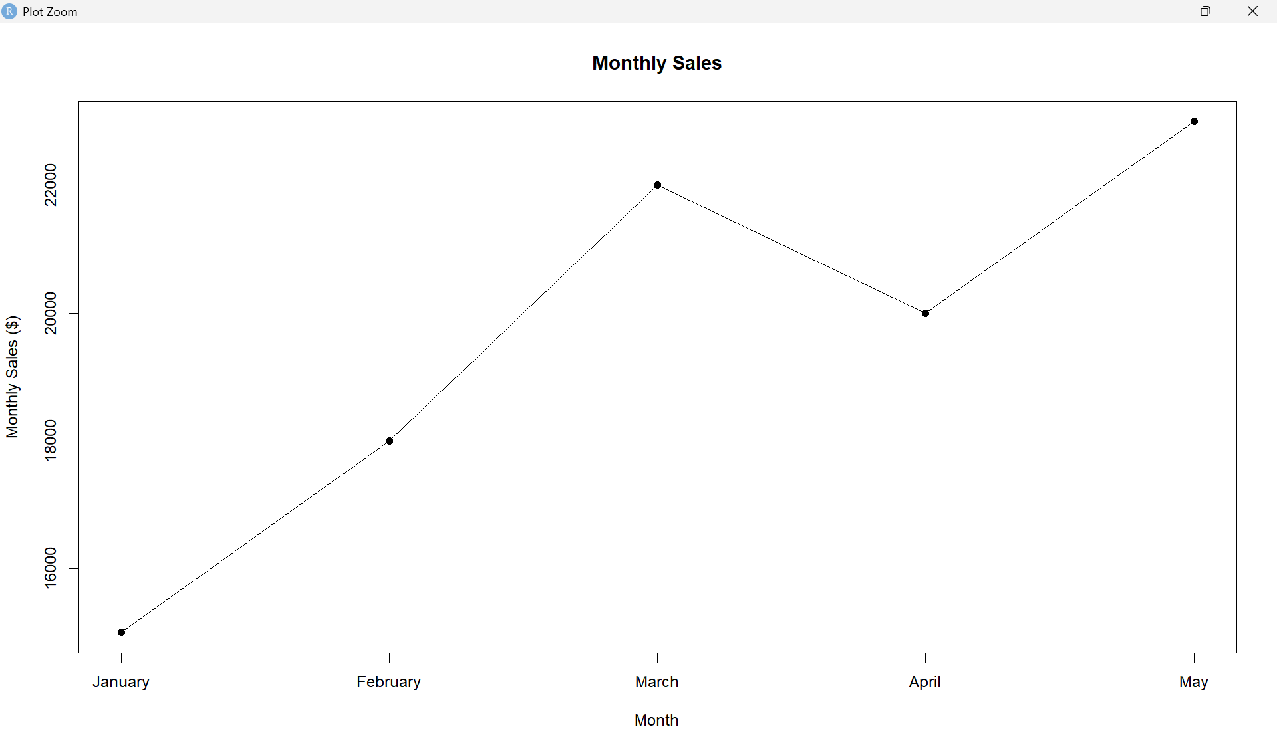

2. Generate a bar chart to display the top-selling products for the year. Label the chart elements.
# Sample product sales data
products <- c("Product A", "Product B", "Product C", "Product D", "Product E")
product_sales <- c(45000, 38000, 52000, 30000, 47000)

# Create bar chart
barplot(product_sales,
names.arg = products,
xlab = "Products",
ylab = "Sales ($)",
main = "Top-Selling Products for the Year",
col = "steelblue",
border = "black")

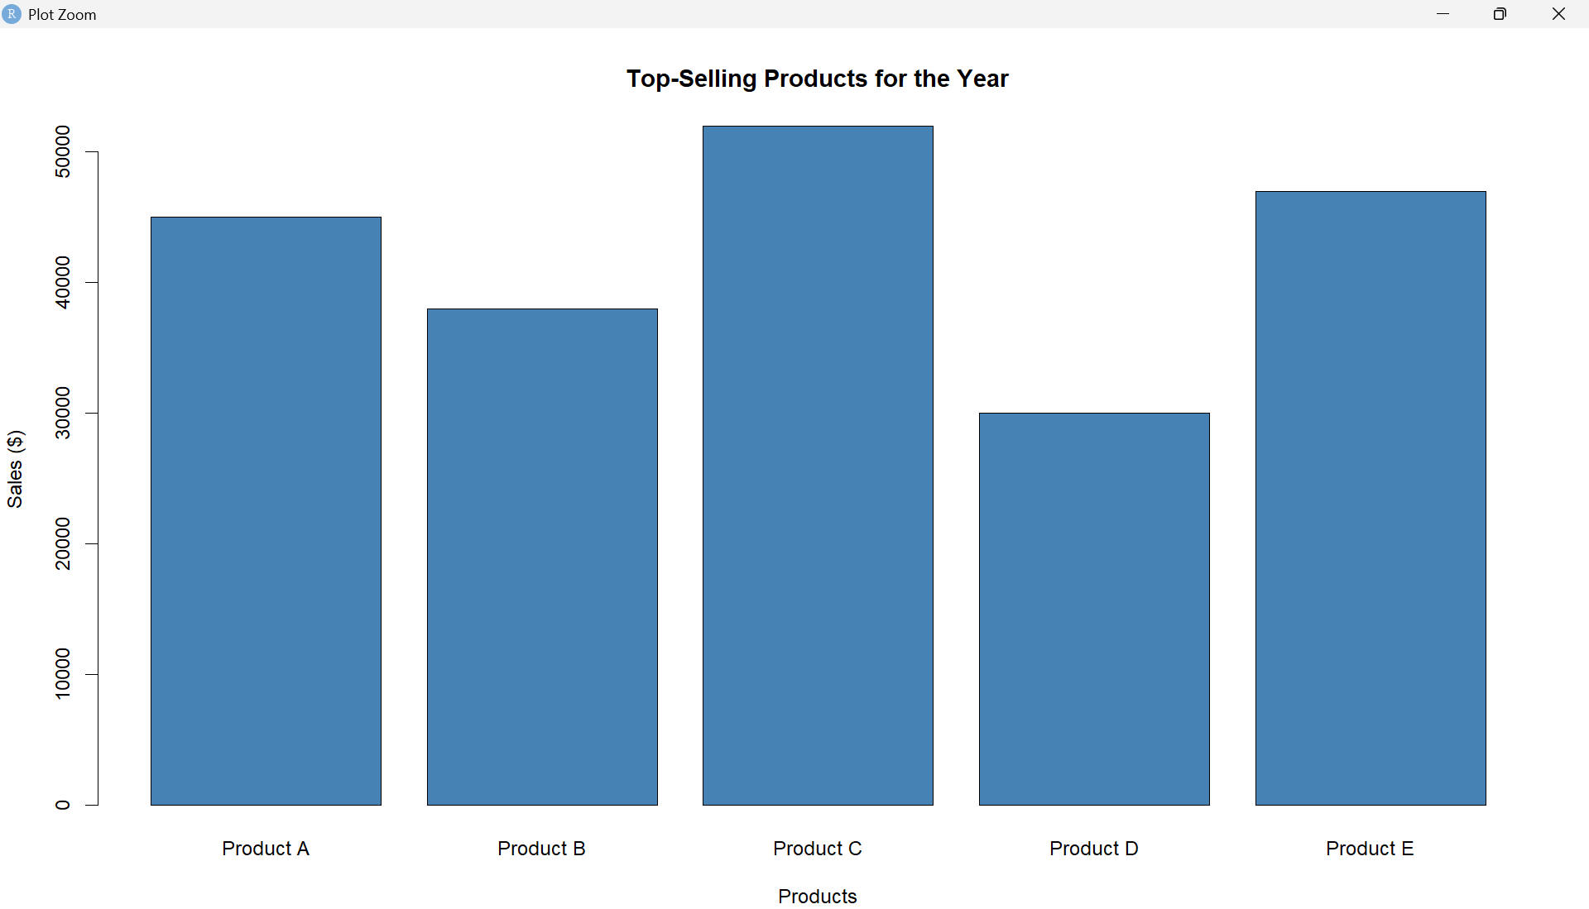

3. Develop a scatter plot to explore the relationship between advertising budget and monthly sales.Explain the insights drawn from the scatter plot.
# Sample advertising budget data
advertising <- c(10, 15, 20, 18, 25)
sales <- c(15000, 18000, 22000, 20000, 23000)

# Create scatter plot
plot(advertising, sales,
xlab = "Advertising Budget ($000)",
ylab = "Monthly Sales ($)",
main = "Advertising Budget vs Monthly Sales",
pch = 19)

# Add trend line
abline(lm(sales ~ advertising),
lty = 2)

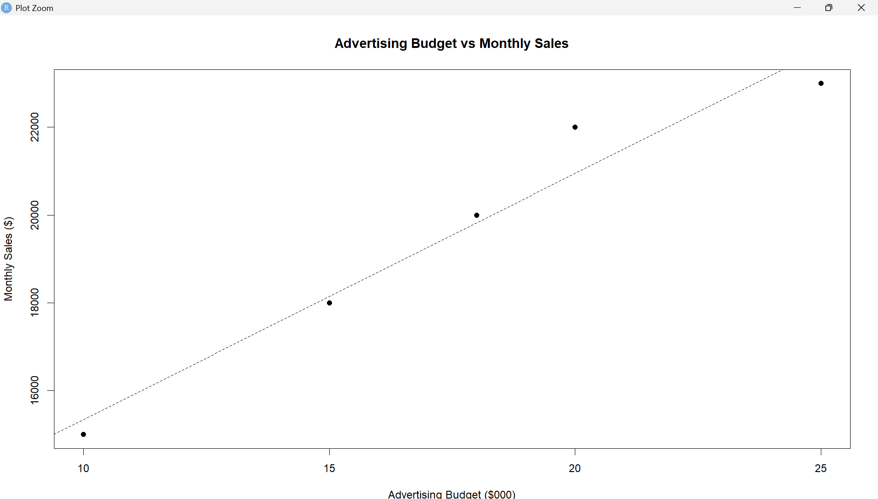
Scatter Plot Insight
The scatter plot shows a positive relationship between advertising budget and monthly sales. In the sample data, months with higher advertising budgets generally have higher sales. For example, the advertising budget of 25 is associated with sales of $23,000, while a budget of 10 is associated with $15,000.
However, this is only a sample dataset with five observations, so it is not enough to establish a strong causal relationship.

4. Build an interactive dashboard combining the line chart and bar chart to allow users to explore sales data interactively.
# ============================================================
# MONTHLY SALES DATA ANALYSIS AND INTERACTIVE DASHBOARD
# ============================================================

# ------------------------------------------------------------
# STEP 1: Install required packages
# ------------------------------------------------------------

packages <- c("shiny", "ggplot2", "plotly")

for (package in packages) {
if (!require(package, character.only = TRUE)) {
install.packages(package)
library(package, character.only = TRUE)
}
}

# Load libraries
library(shiny)
library(ggplot2)
library(plotly)

# ============================================================
# TASK 1: MONTHLY SALES LINE CHART
# ============================================================

# Monthly Sales Dataset
month <- c("January", "February", "March", "April", "May")
sales <- c(15000, 18000, 22000, 20000, 23000)

# Create data frame
sales_data <- data.frame(
Month = month,
Sales = sales
)

# Convert Month into ordered factor
sales_data$Month <- factor(
sales_data$Month,
levels = month
)

# Create line chart
line_chart <- ggplot(
sales_data,
aes(
x = Month,
y = Sales,
group = 1
)
) +
geom_line(linewidth = 1) +
geom_point(size = 3) +
labs(
title = "Monthly Sales",
x = "Month",
y = "Sales ($)"
) +
theme_minimal()

# Display line chart
print(line_chart)

# ============================================================
# TASK 2: TOP-SELLING PRODUCTS BAR CHART
# ============================================================

# Product sales data was not provided.
# Sample data is used for demonstration.

product_data <- data.frame(
Product = c(
"Product A",
"Product B",
"Product C",
"Product D",
"Product E"
),
Sales = c(
45000,
38000,
52000,
30000,
47000
)
)

# Create bar chart
bar_chart <- ggplot(
product_data,
aes(
x = Product,
y = Sales
)
) +
geom_col() +
labs(
title = "Top-Selling Products for the Year",
x = "Product",
y = "Annual Sales ($)"
) +
theme_minimal()

# Display bar chart
print(bar_chart)

# ============================================================
# TASK 3: ADVERTISING BUDGET VS MONTHLY SALES
# ============================================================

# Advertising budget data was not provided.
# Sample data is used for demonstration.

advertising <- c(
10,
15,
20,
18,
25
)

sales <- c(
15000,
18000,
22000,
20000,
23000
)

# Create advertising data frame
advertising_data <- data.frame(
Advertising = advertising,
Sales = sales
)

# Create scatter plot
scatter_chart <- ggplot(
advertising_data,
aes(
x = Advertising,
y = Sales
)
) +
geom_point(size = 3) +
geom_smooth(
method = "lm",
se = FALSE
) +
labs(
title = "Advertising Budget vs Monthly Sales",
x = "Advertising Budget ($000)",
y = "Monthly Sales ($)"
) +
theme_minimal()

# Display scatter plot
print(scatter_chart)

# ============================================================
# TASK 4: INTERACTIVE DASHBOARD
# ============================================================

# User Interface
ui <- fluidPage(

# Dashboard title
titlePanel(
"Monthly Sales Interactive Dashboard"
),

# Sidebar and main panel
sidebarLayout(

# Sidebar
sidebarPanel(

h4("Dashboard Controls"),

# Month selection
checkboxGroupInput(
inputId = "months",
label = "Select Months:",
choices = month,
selected = month
)
),

# Main panel
mainPanel(

# Line chart heading
h3("Monthly Sales"),

# Interactive line chart
plotlyOutput(
outputId = "line_chart"
),

# Bar chart heading
h3("Top-Selling Products"),

# Interactive bar chart
plotlyOutput(
outputId = "bar_chart"
)
)
)
)

# ============================================================
# SERVER
# ============================================================

server <- function(input, output, session) {

# ----------------------------------------------------------
# Filter monthly sales based on selected months
# ----------------------------------------------------------

filtered_sales <- reactive({

data <- sales_data[
sales_data$Month %in% input$months,
]

data
})

# ----------------------------------------------------------
# Interactive Monthly Sales Line Chart
# ----------------------------------------------------------

output$line_chart <- renderPlotly({

p <- ggplot(
filtered_sales(),
aes(
x = Month,
y = Sales,
group = 1,
text = paste(
"Month:",
Month,
"<br>Sales: $",
Sales
)
)
) +

geom_line(
linewidth = 1
) +

geom_point(
size = 3
) +

labs(
title = "Monthly Sales",
x = "Month",
y = "Sales ($)"
) +

theme_minimal()

ggplotly(
p,
tooltip = "text"
)
})

# ----------------------------------------------------------
# Interactive Top-Selling Products Bar Chart
# ----------------------------------------------------------

output$bar_chart <- renderPlotly({

p <- ggplot(
product_data,
aes(
x = Product,
y = Sales,
text = paste(
"Product:",
Product,
"<br>Annual Sales: $",
Sales
)
)
) +

geom_col() +

labs(
title = "Top-Selling Products",
x = "Product",
y = "Annual Sales ($)"
) +

theme_minimal()

ggplotly(
p,
tooltip = "text"
)
})
}

# ============================================================
# RUN INTERACTIVE DASHBOARD
# ============================================================

shinyApp(
ui = ui,
server = server
)

